

Digital Notes
(Subject Name:-Environmental Science and Sustainability)
(Subject Code :-BCA-1006)
BCA
1st year

UNIT-1

Topics to cover: Understanding Environment, Natural Resources, and Sustainability: Fundamental environmental concepts and their relevance to business operations; Components and segments of the environment, the man-environment relationship, and historical environmental movements. Concept of sustainability; Classification of natural resources, Land resources: Minerals, soil, agricultural crops, natural forest products, medicinal plants, and forest-based industries and livelihoods; Land cover, land use change, land degradation, soil erosion, and desertification; Causes of deforestation; Impacts of mining and dam building on forests, biodiversity, and tribal environment, communities. Water resources: Natural and man-made sources; Uses of water; Over exploitation of surface and ground water resources; Floods, droughts, and interstate conflicts international Energy resources: Renewable and non-renewable energy sources; Use of alternate energy sources; Growing energy needs; Energy contents of coal, petroleum, natural gas and bio gas; Agro-residues as a biomass energy source. of resources, considering both The conservation and equitable use intergenerational and intergenerational equity, and the importance of public awareness and education.

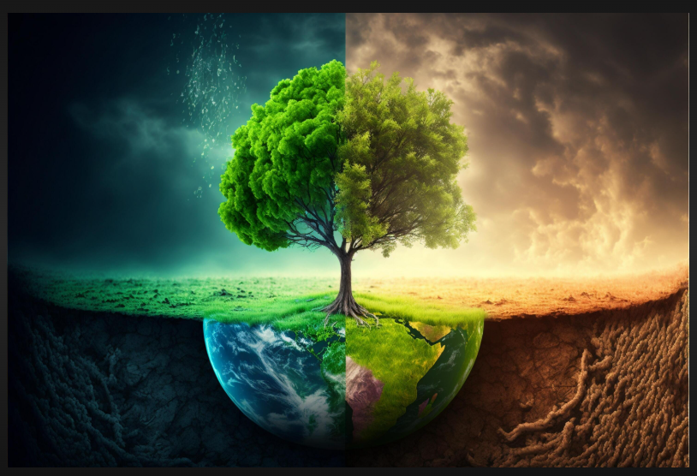

🌍 Understanding Environment, Natural Resources, and Sustainability
1. Fundamental Environmental Concepts & Relevance to Business
- Environment: Surroundings where humans, plants, animals, and other living/non-living things interact.
- Ecosystem: A system where living organisms interact with each other and their physical environment.
- Natural Resources: Materials provided by nature – renewable (air, water, forests, solar energy) and non-renewable (fossil fuels, minerals).
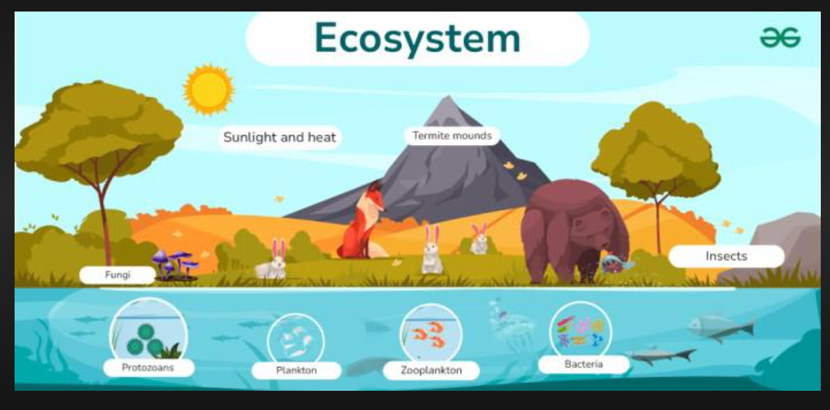
- Relevance to Business:
  - Resource dependency (raw materials, water, energy).
  - Pollution & waste management affect corporate image and compliance.
  - Sustainable practices lower costs and attract eco-conscious consumers.
  - Regulations (Environmental laws, CSR).

2. Components & Segments of the Environment
- Abiotic (Physical): Air, water, soil, minerals, climate.
- Biotic (Living): Plants, animals, humans, microorganisms.
- Segments of Environment:
  - Atmosphere – air & gases, protection from UV rays.
  - Hydrosphere – oceans, rivers, lakes, groundwater.
  - Lithosphere – land, rocks, soil, minerals.
  - Biosphere – life forms and ecosystems.

3. Man–Environment Relationship
- Dependence: Humans depend on environment for food, water, shelter, energy.
- Impact: Industrialization, deforestation, urbanization → pollution, climate change.
- Approaches:
  - Anthropocentric – Nature exists for human benefit.
  - Ecocentric – Humans are part of nature; protection of environment is essential.
- Business Connection: Balancing growth with ecological preservation (sustainable development).

4. Historical Environmental Movements in India
- Chipko Movement (1973, Uttarakhand) – Villagers hugged trees to prevent deforestation.
- Narmada Bachao Andolan (1985) – Protest against large dam projects displacing people & harming ecosystems.
- Silent Valley Movement (1970s, Kerala) – Saved tropical forest from hydroelectric project.
- Bishnoi Movement (1730, Rajasthan) – Amrita Devi & villagers sacrificed lives to protect trees.
- Appiko Movement (1983, Karnataka) – Inspired by Chipko; against deforestation.

5. Concept of Sustainability
- Definition: Meeting present needs without compromising the ability of future generations to meet their own needs (Brundtland Commission, 1987).
- Pillars of Sustainability:
  - Environmental – Protecting ecosystems, reducing waste, conserving resources.
  - Social – Equity, community well-being, fair labor practices.
  - Economic – Efficient use of resources, green technology, long-term profitability.
- Business Practices:
  - Renewable energy adoption.
  - Green supply chain management.
  - Corporate Social Responsibility (CSR).
  - Eco-friendly products & packaging.

🌍 Natural Resources
1. Classification of Natural Resources
A. On the Basis of Origin
- Biotic Resources → derived from living things (forests, crops, animals, fisheries, fossil fuels).
- Abiotic Resources → non-living (air, water, minerals, soil, land).
B. On the Basis of Renewability
- Renewable Resources → can regenerate if used wisely (forests, crops, freshwater, wind, solar).
- Non-renewable Resources → finite and exhaustible (coal, petroleum, natural gas, most minerals).
C. On the Basis of Development
- Actual Resources → discovered and utilized (coal in Jharkhand, petroleum in Assam).
- Potential Resources → exist but not fully exploited (tidal energy in Gujarat).
D. On the Basis of Distribution
- Ubiquitous → found everywhere (air, sunlight, water).
- Localized → available only in specific regions (bauxite in Odisha, crude oil in Middle East).

2. Land Resources
Land is the base for agriculture, habitation, industries, forestry, and mineral exploitation.
a) Minerals
- Naturally occurring inorganic substances with definite chemical composition.
- Types:
  - Metallic minerals → iron ore, bauxite, copper, manganese (used in industries, construction).
  - Non-metallic minerals → mica, limestone, gypsum, salt (used in cement, glass, fertilizers).
  - Energy minerals → coal, petroleum, natural gas, uranium (used for power generation & transport).
- Importance: Backbone of industrial development, export earnings, employment generation.
- Issues: Over-extraction, mining hazards, pollution, depletion of reserves.

b) Soil
- Uppermost fertile layer of land formed by weathering of rocks + organic matter decomposition.
- Major Soil Types in India:
  - Alluvial Soil → fertile, good for rice/wheat (Indo-Gangetic plain).
  - Black Soil → rich in clay, good for cotton (Deccan plateau).
  - Red Soil → less fertile, supports millets & pulses (Tamil Nadu, Karnataka).
  - Laterite Soil → rich in iron, suitable for tea, coffee (Western Ghats, Assam).
  - Desert Soil → sandy, low fertility (Rajasthan).
  - Mountain Soil → thin, supports fruits, tea (Himalayan regions).
- Importance: Agriculture, forestry, natural vegetation.
- Threats: Soil erosion, desertification, salinity, excessive fertilizer use.

c) Agricultural Crops
- Food Crops: Rice, wheat, maize, pulses → ensure food security.
- Cash Crops: Sugarcane, cotton, jute → industrial raw material & export earnings.
- Plantation Crops: Tea, coffee, rubber, coconut → global trade.
- Horticulture Crops: Fruits & vegetables → nutrition & economic value.
- Importance: Employment, income, industrial input, rural livelihood.
- Challenges: Over-dependence on monsoon, soil degradation, pest attacks, climate change.

d) Natural Forest Products
- Timber Products: Teak, sal, rosewood, pine, deodar (used in construction, furniture).
- Non-Timber Forest Products (NTFPs):
  - Bamboo, cane → handicrafts, paper.
  - Gum, resins, lac → industrial & medicinal uses.
  - Honey, fruits, nuts → nutrition & livelihood.
- Ecological Role: Maintains biodiversity, regulates climate, prevents soil erosion, acts as carbon sink.
- Issues: Deforestation, illegal logging, biodiversity loss.

e) Medicinal Plants
- India is a biodiversity hotspot with rich herbal traditions (Ayurveda, Siddha, Unani).
- Examples:
  - Neem → antiseptic, antibacterial.
  - Tulsi → immunity booster, respiratory relief.
  - Aloe vera → skincare, digestion.
  - Ashwagandha → stress relief, vitality.
  - Turmeric → anti-inflammatory, healing.
- Importance: Pharmaceutical industries, traditional medicine, export market.
- Threats: Overharvesting, habitat destruction, loss of traditional knowledge.

f) Forest-Based Industries & Livelihoods
1. Industries Dependent on Forests
- Paper & Pulp → bamboo, eucalyptus; products: paper, packaging.
- Plywood & Furniture → timber (teak, sal); products: furniture, doors.
- Resin, Gum & Medicinal Products → pine resin (paints, adhesives), acacia gum (food, pharma), herbal plants (Ayurveda, pharma exports).
- Bamboo & Cane Handicrafts → baskets, mats, furniture; strong livelihood in North-East India.

2. Livelihoods
- Tribal & Rural Communities → depend on NTFPs (tendu leaves, honey, gum, mahua).
- Provides seasonal income & food security.
- Employment → carpentry, logging, herbal medicine trade, eco-tourism.

3. Challenges
- Deforestation & biodiversity loss.
- Conflicts over forest rights.
- Climate change affecting resources.
- Exploitation by middlemen.

4. Sustainable Solutions
- Social Forestry & Agroforestry – tree planting alongside farming.
- Joint Forest Management (JFM) – community participation.
- Eco-friendly Industries – bamboo furniture, recycled paper.
- Government Initiatives – National Bamboo Mission, TRIFED, Forest Rights Act.

🌍 Land Issues

1. Land Cover
Definition:
Land cover refers to the physical and biological cover on the Earth’s surface, including vegetation, built-up areas, water bodies, bare soil, and artificial structures.
Examples: Forests, grasslands, wetlands, deserts, agricultural land, urban areas.
Importance:
- Maintains ecological balance (forests regulate climate, wetlands store water).
- Provides habitats for biodiversity.
- Acts as a carbon sink (forests absorb CO₂).
Issues:
- Large-scale deforestation for agriculture and industries.
- Urban sprawl replacing fertile agricultural land.
- Loss of wetlands due to drainage for settlements.
Solutions:
- Remote sensing & GIS monitoring.
- Afforestation and forest conservation.
- Urban planning to protect agricultural land.

2. Land Use Change
Definition:
Land use change is the alteration of land for human purposes, such as converting forests into farms, grasslands into cities, or agricultural land into industrial zones.
Causes:
- Population growth and urbanization.
- Industrialization and infrastructure projects (dams, highways).
- Shifting cultivation, mining, and deforestation.
Impacts:
- Habitat destruction → loss of biodiversity.
- Decline in soil fertility due to overuse.
- Climate change (loss of carbon-absorbing forests).
- Conflict over land ownership/usage.
Solutions:
- Sustainable land-use planning.
- Promotion of mixed land use (agroforestry, eco-tourism).
- Strict laws against illegal encroachments.

3. Land Degradation
Definition:
Land degradation is the decline in the quality and productivity of land, caused by natural processes and human activities.
Causes:
- Deforestation, overgrazing.
- Excessive irrigation → waterlogging & salinity.
- Mining, industrial pollution, urban waste dumping.
- Unsustainable agriculture (overuse of fertilizers/pesticides).
Effects:
- Reduction in soil fertility.
- Decline in agricultural productivity.
- Food insecurity and rural poverty.
- Disturbance of ecosystems and water cycles.
Solutions:
- Soil conservation techniques (terracing, contour plowing).
- Organic farming & reduced chemical use.
- Land reclamation from mines/wastelands.
- Community participation in land restoration.

4. Soil Erosion
Definition:
Soil erosion is the removal of the top fertile layer of soil by agents such as water, wind, or human activities.
Causes:
- Deforestation & overgrazing.
- Improper farming methods (monocropping, slash-and-burn).
- Construction and mining.
- Natural disasters (floods, storms).
Types:
- Sheet erosion – uniform removal of thin layers of soil.
- Rill erosion – formation of small channels on the surface.
- Gully erosion – deep, wide channels formed (e.g., Chambal ravines in India).
- Wind erosion – common in arid regions (Thar Desert).
Effects:
- Loss of soil fertility.
- Siltation of rivers, lakes, and dams.
- Decline in crop yield → food insecurity.
- Increased desertification.
Solutions:
- Afforestation and shelter belts.
- Contour plowing and terracing.
- Strip cropping & crop rotation.
- Check dams to reduce water runoff.

5. Desertification
Definition:
Desertification is the process by which fertile land becomes desert-like, losing its productivity due to degradation, deforestation, and climate factors.
Causes:
- Overgrazing of pastures.
- Deforestation → loss of vegetation cover.
- Unsustainable irrigation → salinity & waterlogging.
- Climate change → rising temperatures, reduced rainfall.
Effects:
- Expansion of desert areas (e.g., Thar Desert spreading).
- Loss of agricultural land → rural poverty & migration.
- Decline in groundwater recharge.
- Threat to biodiversity.
Solutions:
- Afforestation & reforestation (planting drought-resistant trees).
- Sustainable grazing and water management.
- Use of organic farming & soil conservation.
- Global efforts like UNCCD (United Nations Convention to Combat Desertification).

✅ Summary:
- Land Cover → what is on the surface.
- Land Use Change → how humans modify land.
- Land Degradation → loss of land productivity.
- Soil Erosion → removal of fertile topsoil.
- Desertification → transformation of fertile land into desert.

🌳 Deforestation
Definition:
Deforestation is the large-scale removal or clearing of forest cover, where forest land is converted into non-forest uses such as agriculture, urbanization, mining, or infrastructure development. It disrupts ecological balance, reduces biodiversity, and contributes to climate change.
Key Points:
- Reduces natural habitat for wildlife (leads to species extinction).
- Contributes to global warming through increased CO₂ emissions.
- Leads to soil erosion, land degradation, and loss of fertility.
- Affects water cycle and rainfall patterns.

🔎 Causes of Deforestation
- Agricultural Expansion
  - Forests are cleared for crops (like soybean, palm oil) and livestock grazing.
  - Slash-and-burn farming in tribal and rural areas.
- Urbanization & Infrastructure Development
  - Roads, highways, dams, and housing projects encroach upon forests.
  - Industrial expansion requires land and resources.
- Logging & Timber Extraction
  - Demand for wood, paper, plywood, and furniture.
  - Illegal logging accelerates the process.
- Mining Activities
  - Extraction of coal, bauxite, iron ore, etc., requires clearing large tracts of forests.
  - Leads to displacement of local communities and loss of biodiversity.
- Fuelwood & Charcoal
  - Rural and tribal populations depend on forests for firewood and fuel.
  - Overharvesting leads to forest depletion.
- Forest Fires
  - Natural (lightning) or human-made fires (shifting cultivation, negligence).
  - Destroy vast areas rapidly and alter soil composition.
- Shifting Cultivation (Jhuming)
  - Practiced in North-East India and tribal belts.
  - Forests are cut and burned for temporary farming, then abandoned.
- Population Pressure
  - Growing population increases demand for land, housing, and resources.
  - Encroachment on forest land for settlements.
- Climate Change
  - Rising temperatures and irregular rainfall can also stress forests, making them prone to degradation and clearing.

Mining and Dam Building: Impacts on Environment and Society

1. Impacts on Forests
- Deforestation: Large areas of forest are cleared for mining pits, dam reservoirs, and related infrastructure.
- Loss of vegetation cover: Leads to habitat destruction and disrupts ecological balance.
- Microclimatic changes: Reduced forest cover alters rainfall patterns, temperature, and soil moisture.
- Fragmentation: Forests get divided into smaller patches, affecting wildlife movement and survival.

2. Impacts on Biodiversity
- Habitat Loss: Many plant and animal species lose their natural habitat due to deforestation and submergence of land under dams.
- Threat to Endangered Species: Mining and dams often affect ecologically sensitive regions, leading to the extinction risk of rare flora and fauna.
- Aquatic Biodiversity: Dams alter river flow, block fish migration routes, and reduce aquatic species diversity.
- Ecosystem Imbalance: Removal of forests and soil disruption reduces food chains and ecosystem services.

3. Impacts on Tribal Environment and Communities
- Displacement: Tribal people living in forested or river valley regions are displaced due to land acquisition for mining projects or dam construction.
- Loss of Livelihoods: Tribals depend on forests (NTFPs like firewood, fruits, medicinal plants) and rivers (fishing, agriculture). These resources vanish.
- Cultural Erosion: Forests and rivers are deeply tied to tribal traditions, beliefs, and festivals. Their displacement leads to loss of culture.
- Health Hazards: Mining activities cause air, water, and soil pollution, affecting the health of nearby communities.
- Conflict & Rights Issues: Many projects neglect the rights of indigenous people, leading to social unrest and conflicts.
4. Other Environmental Impacts
- Soil erosion and land degradation.
- River water pollution and siltation (dams reduce downstream fertility).
- Greenhouse gas emissions (from reservoirs like methane).
- Landslides and geological instability in mining regions.
5. Mitigation and Sustainable Practices
- Afforestation and compensatory plantation.
- Proper resettlement & rehabilitation (R&R) policies.
- Adoption of eco-friendly mining techniques.
- Environmental Impact Assessment (EIA) before projects.
- Promotion of small-scale, community-based hydropower.

🌊 Water Resources
Definition
Water resources refer to all sources of water available on the earth’s surface and underground that can be used for human, agricultural, industrial, and ecological purposes.

1. Natural Sources of Water
Water occurring naturally in the environment.
- Surface Water – rivers, lakes, ponds, seas, oceans.
- Groundwater – wells, springs, aquifers.
- Rainwater – primary source replenishing surface and groundwater.
- Glaciers & Icecaps – store freshwater, melting feeds rivers.

2. Man-made Sources of Water
Artificially created structures to store or supply water.
- Dams & Reservoirs – store water for irrigation, drinking, and hydropower.
- Canals – distribute water for agriculture.
- Tanks & Ponds – traditional rainwater harvesting systems.
- Wells & Tube Wells – for groundwater extraction.

3. Uses of Water
- Domestic Use – drinking, cooking, cleaning, sanitation.
- Agriculture – irrigation, livestock.
- Industrial Use – cooling, processing, manufacturing.
- Hydropower Generation – electricity production.
- Recreational Use – tourism, fisheries, boating.
- Ecological Use – sustaining ecosystems, wetlands, biodiversity.

4. Over-exploitation of Surface & Ground Water Resources
Excessive and unsustainable use of water resources.
- Over-irrigation → waterlogging, salinity.
- Groundwater depletion → falling water tables, dry wells.
- River diversion → reduced flow, drying of wetlands.
- Industrial & Urban demand → stress on resources.

5. Floods
Definition: Natural disaster caused by overflow of water submerging land.
- Causes: Heavy rainfall, dam failures, river overflow, poor drainage.
- Impacts: Loss of lives, damage to crops, soil erosion, spread of diseases.

6. Droughts
Definition: Prolonged period of deficient rainfall leading to water scarcity.
- Types:
  - Meteorological drought (less rainfall)
  - Agricultural drought (soil moisture deficit)
  - Hydrological drought (reduced surface/groundwater)
- Impacts: Crop failure, famine, livestock death, migration, desertification.

7. Interstate Conflicts (India examples)
Definition: Disputes between states over sharing river water.
- Cauvery Water Dispute – Karnataka vs Tamil Nadu.
- Krishna River Dispute – Maharashtra, Karnataka, Andhra Pradesh, Telangana.
- Satluj-Yamuna Link Canal – Punjab vs Haryana.

8. International Conflicts
Definition: Disputes between countries over transboundary rivers.
- Indus Water Treaty (India–Pakistan) – sharing Indus river water.
- Ganga Water Treaty (India–Bangladesh) – sharing Ganga at Farakka Barrage.
- Brahmaputra River Issue (India–China) – concerns over upstream dam building.

Energy Resources
Energy resources are the natural sources from which humans derive energy for performing activities like cooking, heating, transportation, agriculture, and industrial production.
They can be broadly classified into Renewable and Non-renewable sources.

1. Renewable Energy Sources
🔹 Definition: Renewable energy sources are those which can be naturally replenished within a short time and are sustainable.
🔹 Examples: Sunlight, wind, water, biomass, geothermal energy.
Key Types:
- Solar Energy → Energy from the Sun (used in solar panels, solar heaters).
- Wind Energy → Generated using wind turbines.
- Hydropower → Energy from flowing water (dams, turbines).
- Biomass → Organic matter (wood, crop residues, dung) used as fuel.
- Geothermal → Heat energy from the Earth’s interior.
- Tidal & Wave Energy → From sea tides and ocean waves.
✅ Advantages: Clean, renewable, eco-friendly.
❌ Limitation: High installation cost, location-specific.

2. Non-Renewable Energy Sources
🔹 Definition: Energy resources that exist in limited quantity and cannot be replenished on a human timescale.
🔹 Examples: Coal, petroleum, natural gas, nuclear fuel (uranium).
Key Types:
- Coal → Major fuel for electricity generation.
- Petroleum (oil) → Used in transport, industries, petrochemicals.
- Natural Gas → Cleaner fossil fuel used in cooking, power plants.
- Nuclear Energy → From uranium or thorium in nuclear reactors.
✅ Advantages: High energy output.
❌ Limitation: Limited reserves, pollution, climate change.

3. Use of Alternate Energy Sources
Definition:
Alternate energy sources are non-conventional energy options that can replace or supplement fossil fuels to meet energy demand sustainably.
- Why Needed:
  - Climate change (reduce greenhouse gas emissions).
  - Fossil fuel depletion (oil, coal reserves are limited).
  - Energy security (reduce dependence on imports).
- Examples:
  - Solar Energy – Solar panels (PV cells), solar thermal systems.
  - Wind Energy – Wind turbines for electricity.
  - Hydropower – Large and small dams, run-of-river projects.
  - Biogas – Produced from animal dung, kitchen waste, sewage.
  - Hydrogen Fuel Cells – Clean fuel, produces only water as byproduct.
  - Nuclear Fusion (future) – Huge potential, but still in research stage.
- Government Support:
  - Subsidies for solar/wind projects.
  - Public awareness programs.
  - Research and Development investments.

4. Growing Energy Needs
Definition:
Growing energy needs refer to the increasing demand for energy caused by social, economic, and demographic changes.
- Causes:
  - Industrialization – Factories, machinery, automation.
  - Urbanization – Housing, transport, electricity needs.
  - Population Growth – More people = higher consumption.
  - Lifestyle Changes – Use of gadgets, vehicles, air conditioners, etc.
- Indicator:
  - Per capita energy consumption is used as a measure of development.
  - Developed countries consume much more energy per person than developing ones.
- Challenge:
  - Need to balance growth with sustainability (avoid resource exhaustion and pollution).

5. Energy Content of Fuels
Definition:
The energy content of a fuel is the amount of heat or energy released when a specific amount of fuel is completely burned.
- Measurement Unit:
  - Usually measured in kilojoules (kJ) or megajoules (MJ) per kilogram or cubic meter.
- Values:
  - Coal → 20–25 MJ/kg
  - Petroleum (oil) → 42–47 MJ/kg
  - Natural Gas → 35–45 MJ/m³
  - Biogas → 20–25 MJ/m³
- Observation:
  - Petroleum has the highest energy content per unit weight, hence widely used in transport.

6. Agro-Residues as Biomass Energy Source
Definition:
Agro-residues are the leftover materials from farming and agriculture that can be used to produce energy.
- Examples:
  - Husk (rice husk, wheat husk)
  - Straw (wheat, paddy)
  - Stalks (cotton, maize, jowar)
  - Sugarcane Bagasse – leftover after juice extraction.
  - Groundnut shells, coconut shells.
- Conversion Methods:
  - Direct Burning – Cooking, heating, rural industries.
  - Biogas Production – Anaerobic digestion of residues with microbes.
  - Biofuels – Ethanol (from sugarcane, maize), biodiesel (from oil seeds).
- Advantages:
  - Low-cost, renewable, reduces waste.
  - Provides rural employment.
  - Reduces dependence on fossil fuels.
- Limitations:
  - Low efficiency compared to modern fuels.
  - Air pollution from open burning.
  - Collection, storage, and transport issues.

Conservation and Equity

1. Conservation of Resources
- Definition: Sustainable management and protection of natural resources (air, water, soil, minerals, forests, biodiversity) so that they can be used by present and future generations.
- Methods of Conservation:
  - Reduce, Reuse, Recycle (3Rs) – minimize waste and promote resource efficiency.
  - Afforestation & Reforestation – restore degraded lands, increase green cover.
  - Energy Conservation – efficient appliances, renewable sources, public transport.
  - Water Conservation – rainwater harvesting, drip irrigation, watershed management.
  - Wildlife & Biodiversity Protection – protected areas, national parks, sanctuaries.
  - Pollution Control – cleaner technologies, emission standards, waste management.
- Need for Conservation:
  - Prevents resource depletion.
  - Protects ecological balance.
  - Supports sustainable economic growth.

2. Equitable Use of Resources
- Meaning: Resources should be distributed fairly among all sections of society and nations.
- Why Needed:
  - Prevents conflict between rich and poor regions/countries.
  - Avoids exploitation of weaker communities.
  - Ensures that all have access to basic needs like clean water, food, and energy.
- Example:
  - Developed countries consume a large share of energy resources, while developing countries struggle for access.
  - Policies like carbon credits and global agreements (Paris Climate Agreement) aim to reduce such inequalities.

3. Intergenerational Equity (Between Generations)
- Definition: Fair use of resources in such a way that future generations are not deprived.
- Principle: “We have not inherited the earth from our ancestors, we have borrowed it from our children.”
- Application:
  - Avoid overexploitation of fossil fuels and forests.
  - Shift to renewable resources.
  - Long-term sustainable development planning.
- Examples:
  - Preserving biodiversity hotspots.
  - Limiting groundwater overuse.
  - Reducing greenhouse gas emissions to prevent future climate disasters.

4. Intragenerational Equity (Within the Same Generation)
- Definition: Fair and just use of resources within the same generation (among different sections of society and nations).
- Focus:
  - Reduce the gap between rich and poor.
  - Provide equal access to food, energy, clean air, and water.
- Examples:
  - Subsidized LPG/solar cookers for rural households.
  - Providing affordable electricity and internet in rural areas.
  - Fair trade policies to support farmers and small producers.

5. Importance of Public Awareness and Education
- Why Important:
  - People’s lifestyle and consumption habits directly impact resource use.
  - Without awareness, conservation policies cannot be implemented effectively.
- Ways to Create Awareness:
  - Education – Environmental studies in schools/colleges.
  - Campaigns & Media – Use of TV, social media, NGOs for awareness drives.
  - Workshops & Training – Community-level participation in conservation projects.
  - Celebrations – World Environment Day, Earth Hour, Energy Conservation Week.
- Benefits:
  - Encourages responsible consumption.
  - Promotes sustainable living (e.g., using public transport, eco-friendly products).
  - Builds pressure on governments and industries for eco-friendly policies.

